Soliquid
Do all liquids behave the same way?
Issac Newton (1643 – 1727) was a famous scientist and mathematician. He described how normal liquids (or Newtonian liquids), like water at room temperature, flow - how fluid flows is called ‘viscosity’.
However, some fluids (like oobleck) behave differently and are known as ‘non-Newtonian’ fluids.
What to do
Work in small groups and don’t forget to write your observations in the results table below.
In the experiment you will investigate the viscosity of different fluids and decide whether they are Newtonian or non-Newtonian fluids.
Measuring viscosity
- Take 6 bowls, a timer and a mass balance (weighing scales).
- Put one bowl on the mass balance and use the timer to time how long it takes to pour 50 g of water into the bowl, then repeat this with oil.
- Repeat this with the honey and ketchup – make sure you use a new bowl each time
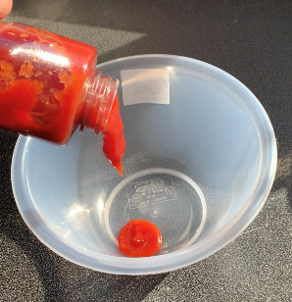
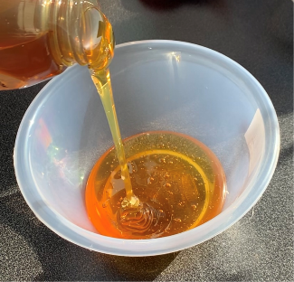
Be a careful scientist and try to pour all liquids the same way so the experiment is fair
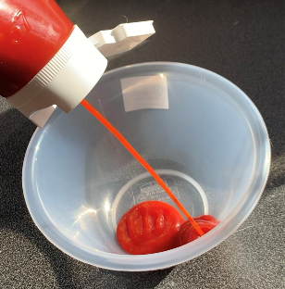
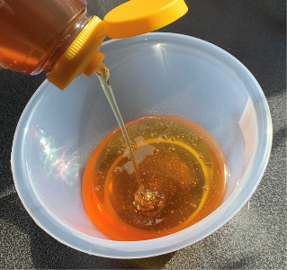
- Weigh out another 50g of honey and ketchup, pour them in two bowls with a nozzle and time it.
- Weigh out 20g water and 30g cornstarch, mix them together in a bowl, pour them in another bowl and time it.
How the fluid behaves
- Drop a steel ball onto every fluid – what happened?
- Hit every fluid with a spoon – what happened?
Using your results decide which was the most viscous fluid (which will be the one that takes the longest time to pour into the bowl).
If you want help with the experiments then watch this video (you may need to ask an adult to help): https://youtu.be/sFJlIhFWrg8
Results table
It is important to record your results so use the table below to write down what happens.
Fluid | Water | Honey | Oil | Ketchup | Cornflour in water
Time (s)
Did the steel ball sink straight away?
What happened when hit with a spoon?
Viscosity ranking*
Is it a Newtonian or non-Newtonian fluid?
*1 is the least viscous (shortest to pour) and 5 is the most viscous (longest tome to pour)
What did you find out?
What might you use non-Newtonian fluids for? Can it be used as body armour?

What other non-Newtonian fluids can you find in your house?

