**To prepare replacement UV Sun Index charts**

1. Print in colour, two sided
2. Cut out
3. Laminate

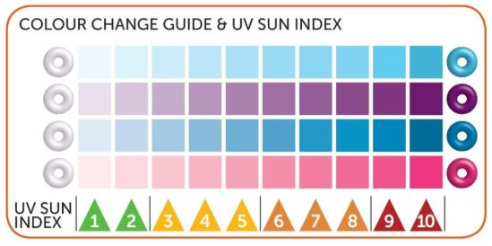



This UV sun index chart was downloaded form the Royal Society of Chemistry website as part of their ‘Mission Starlight’ Global experiment: Downloaded from the Royal Society of Chemistry website: <https://edu.rsc.org/download?ac=15361>

This UV sun index chart was downloaded form the Royal Society of Chemistry website as part of their ‘Mission Starlight’ Global experiment: Downloaded from the Royal Society of Chemistry website: <https://edu.rsc.org/download?ac=15361>